|  |  |  |
| --- | --- | --- |
| **LAB221Assignment** | **Type:** | **LongAssignment** |
| **Code:** | **J2.L.P0001** |
| **LOC:** | **200** |
| **Slot(s):** | **2** |

**Title: Items Management Software**

**Program Specifications**

**The database structure as follow:**

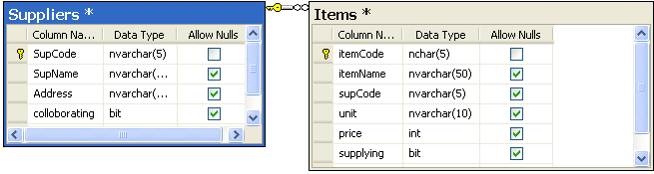

**The project structure is organized as follows:**

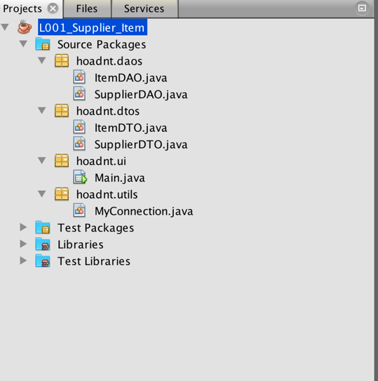

**Supplier management:**

The program has the following basic functions:

- When you click on the table, the supplier's details are displayed in detail.

- Add a new supplier

- Edit supplier information: edit supplier information

- Delete a supplier: delete the supplier only when this supplier has no items. A confirm message is displayed before the delete action.

- After performing the task, a notification message is displayed to the user.

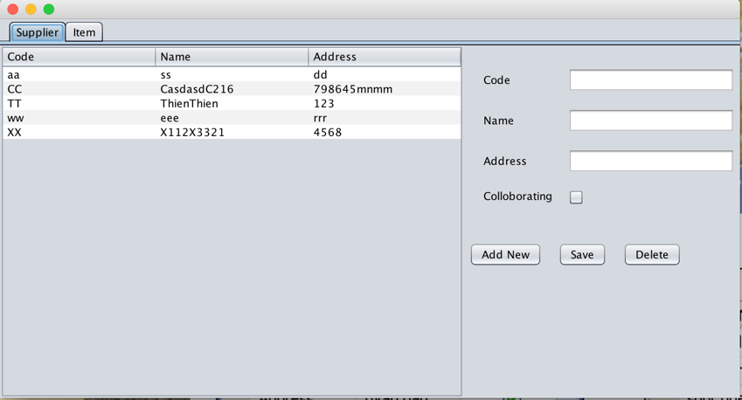

**Item management:**

The program has the following basic functions:

- When you click on the table, the item's details are displayed in detail.

- Add a new item

- Edit item information: edit item information

- Delete an item: delete the selected item. A confirm message is displayed before the delete action.

- After performing the task, a notification message is displayed to the user.

